# Object Localization

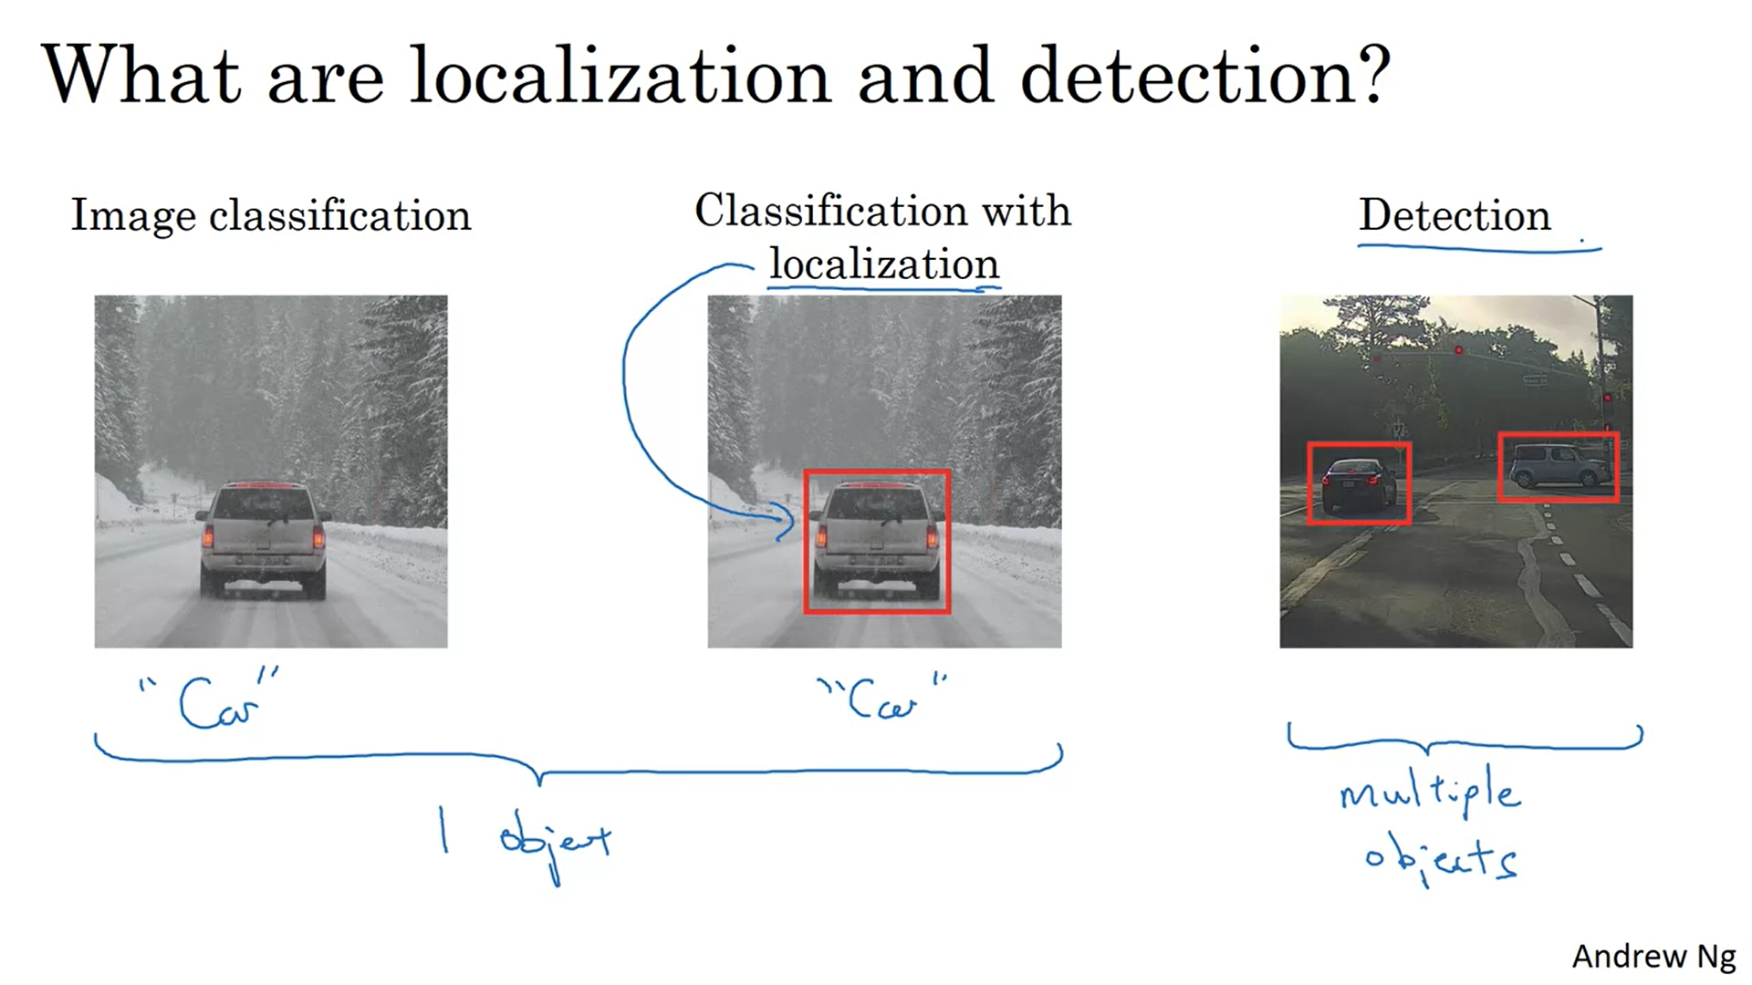

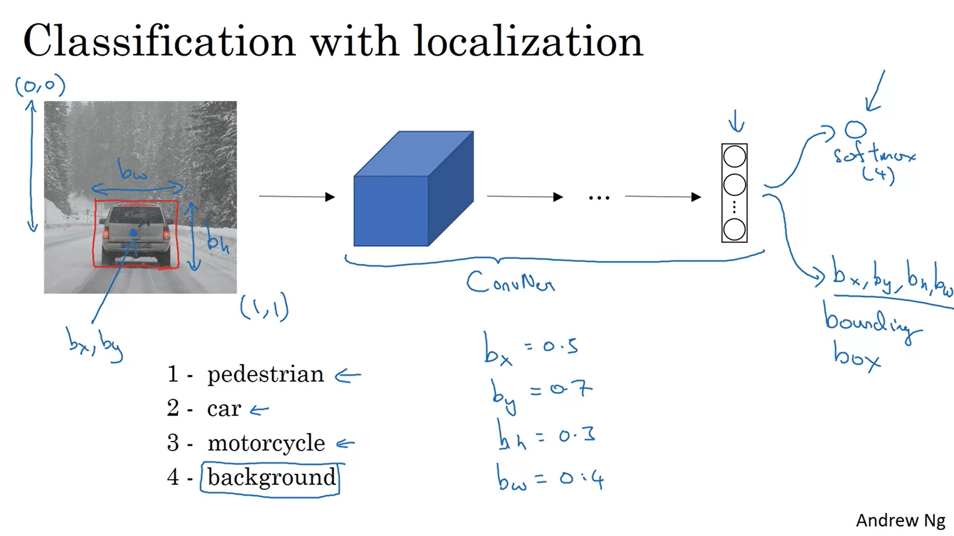

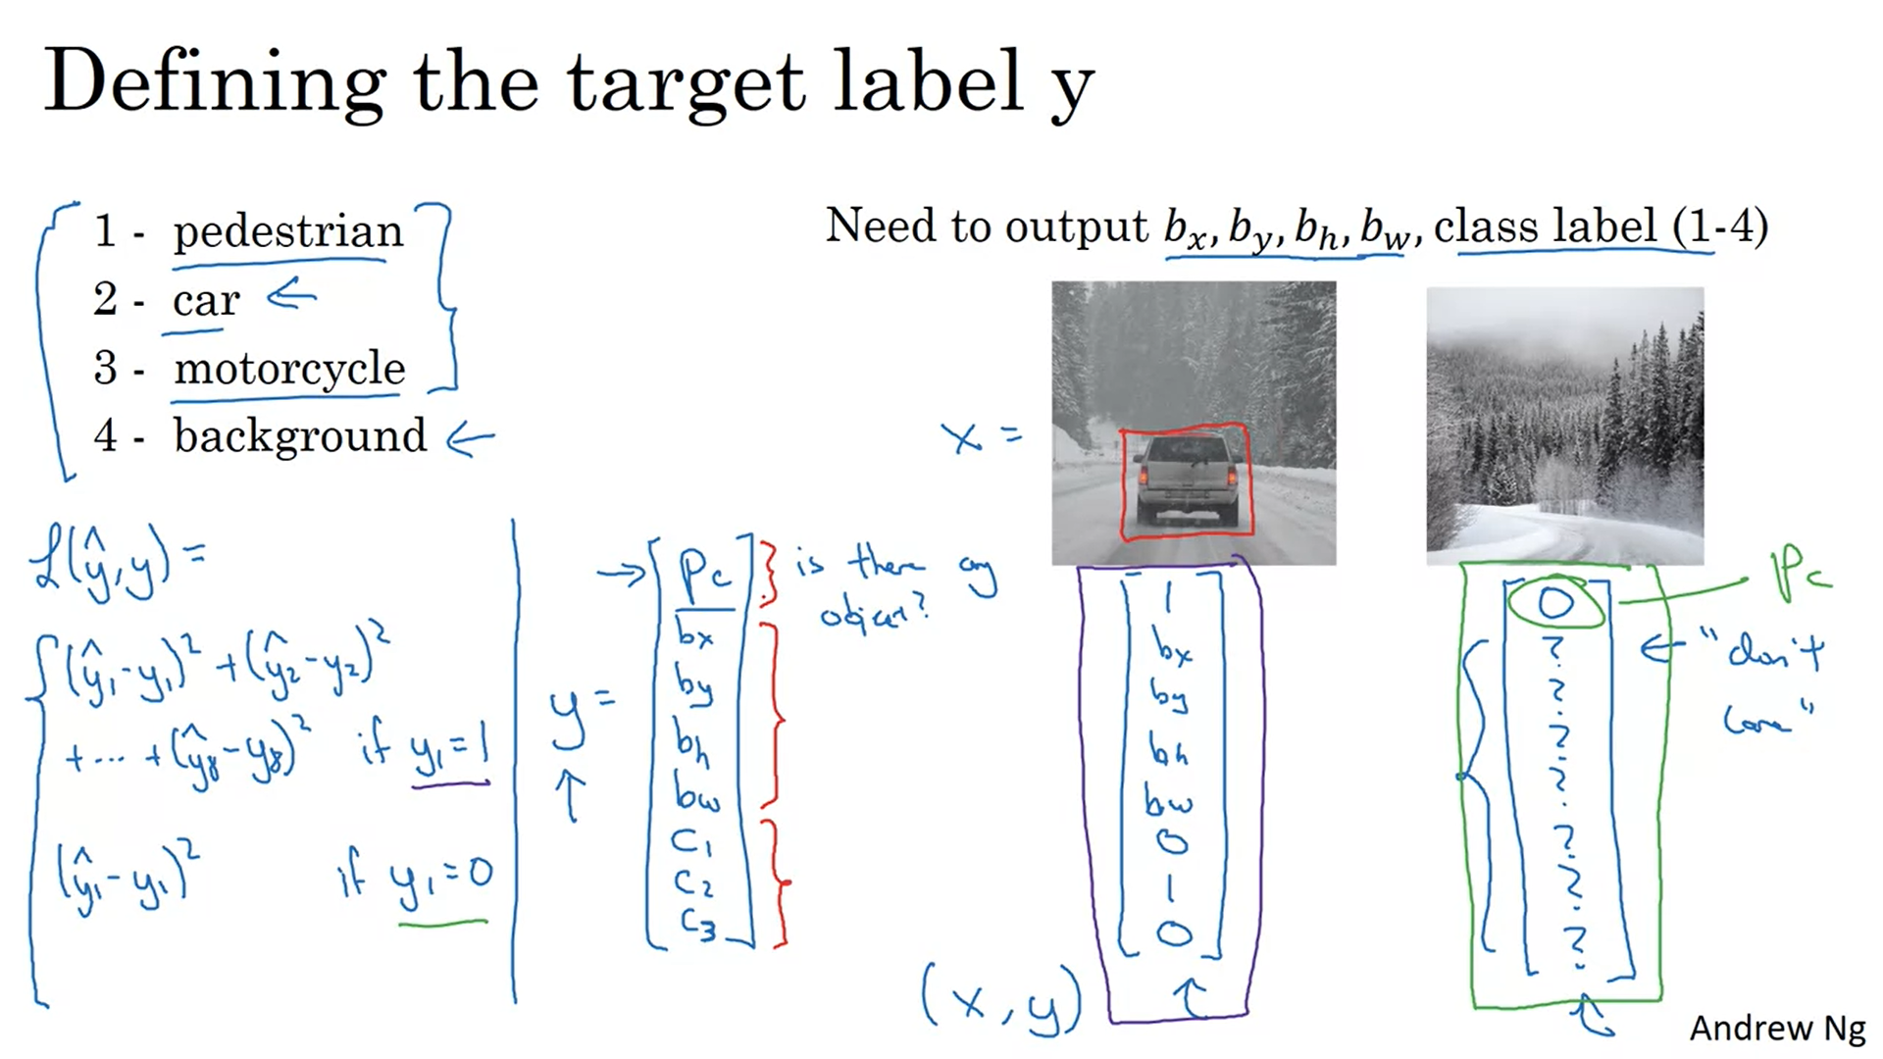

# Landmark Detection

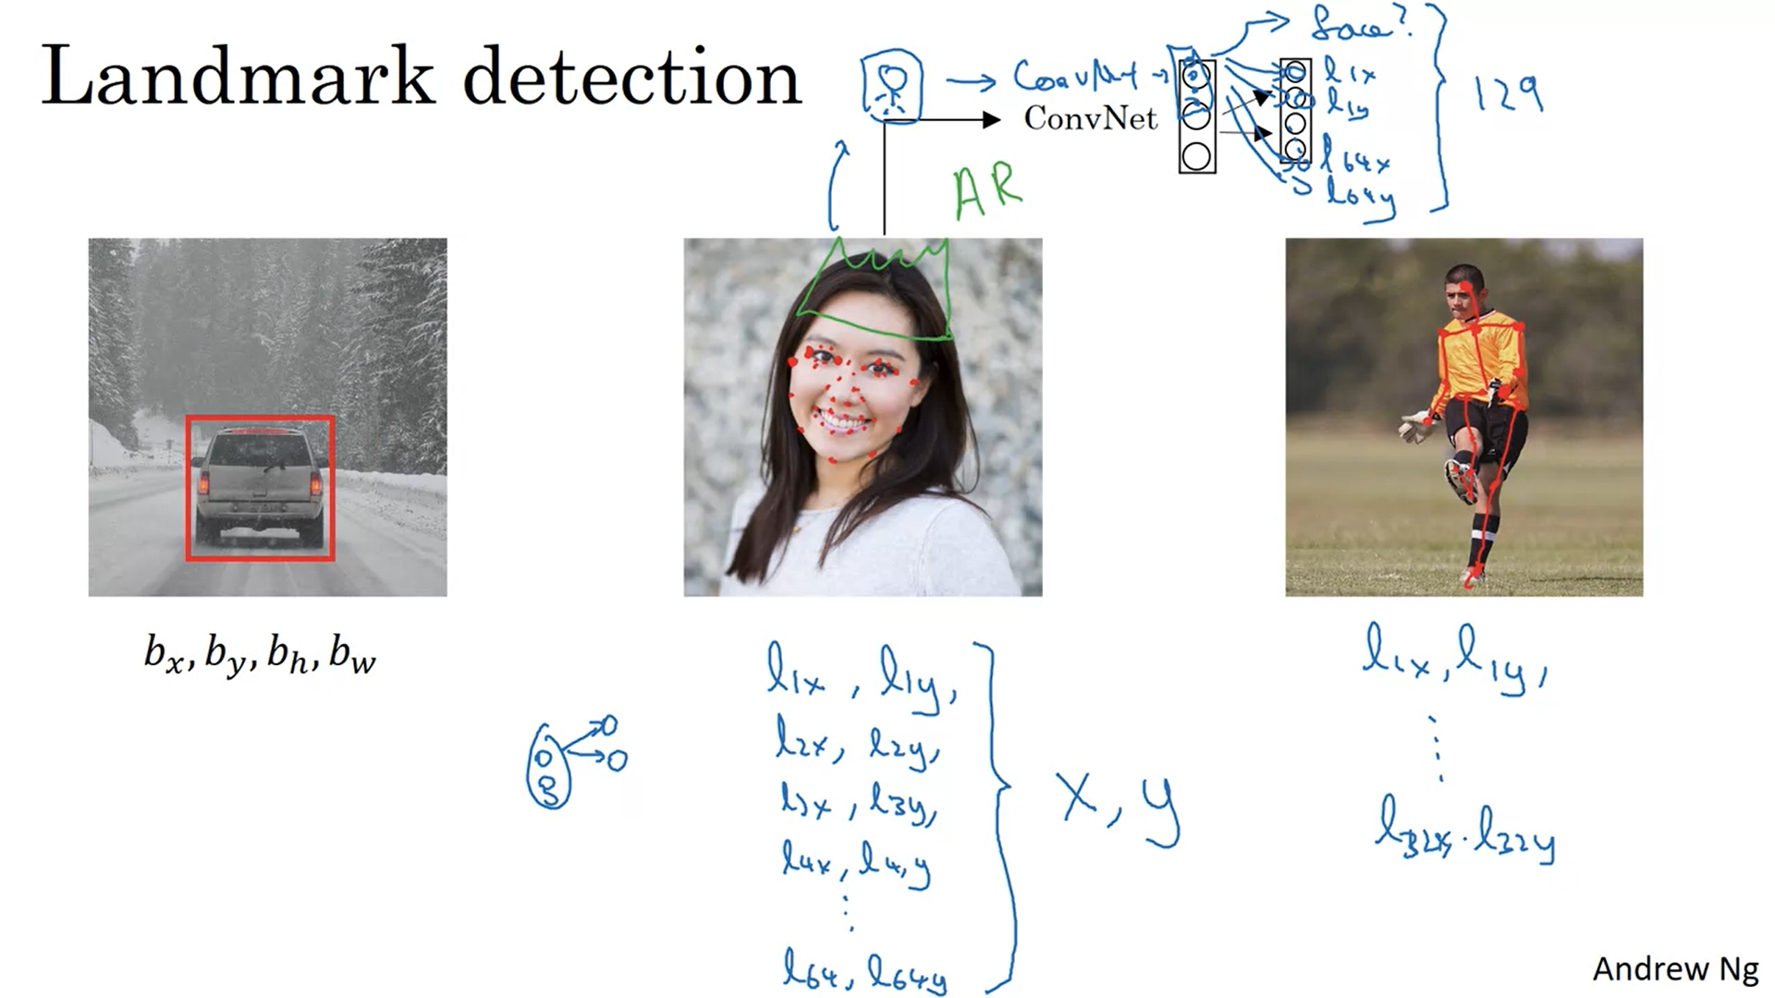

# Object Detection

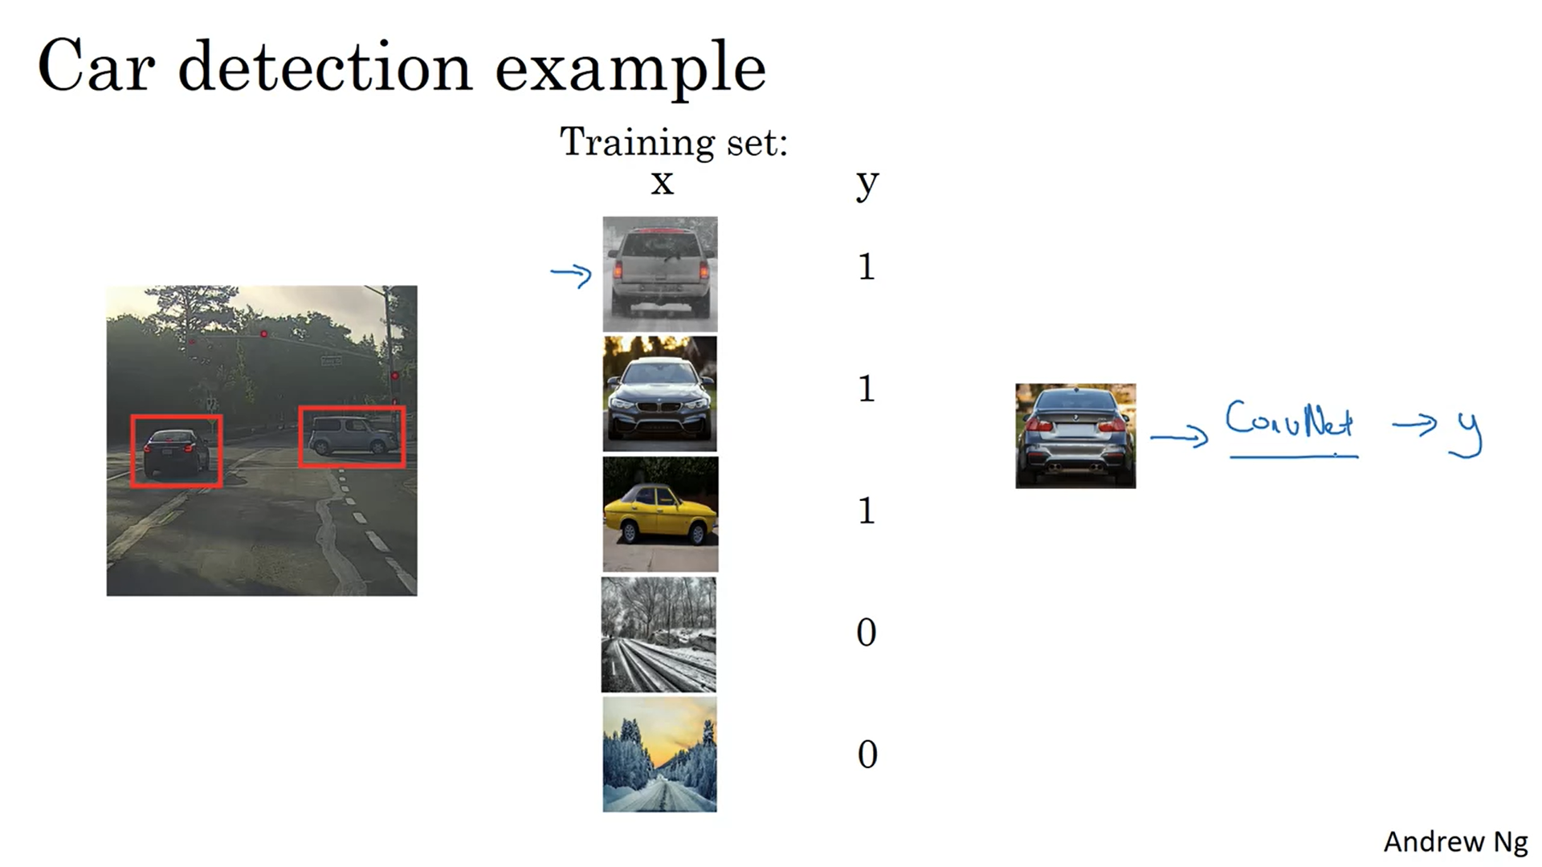

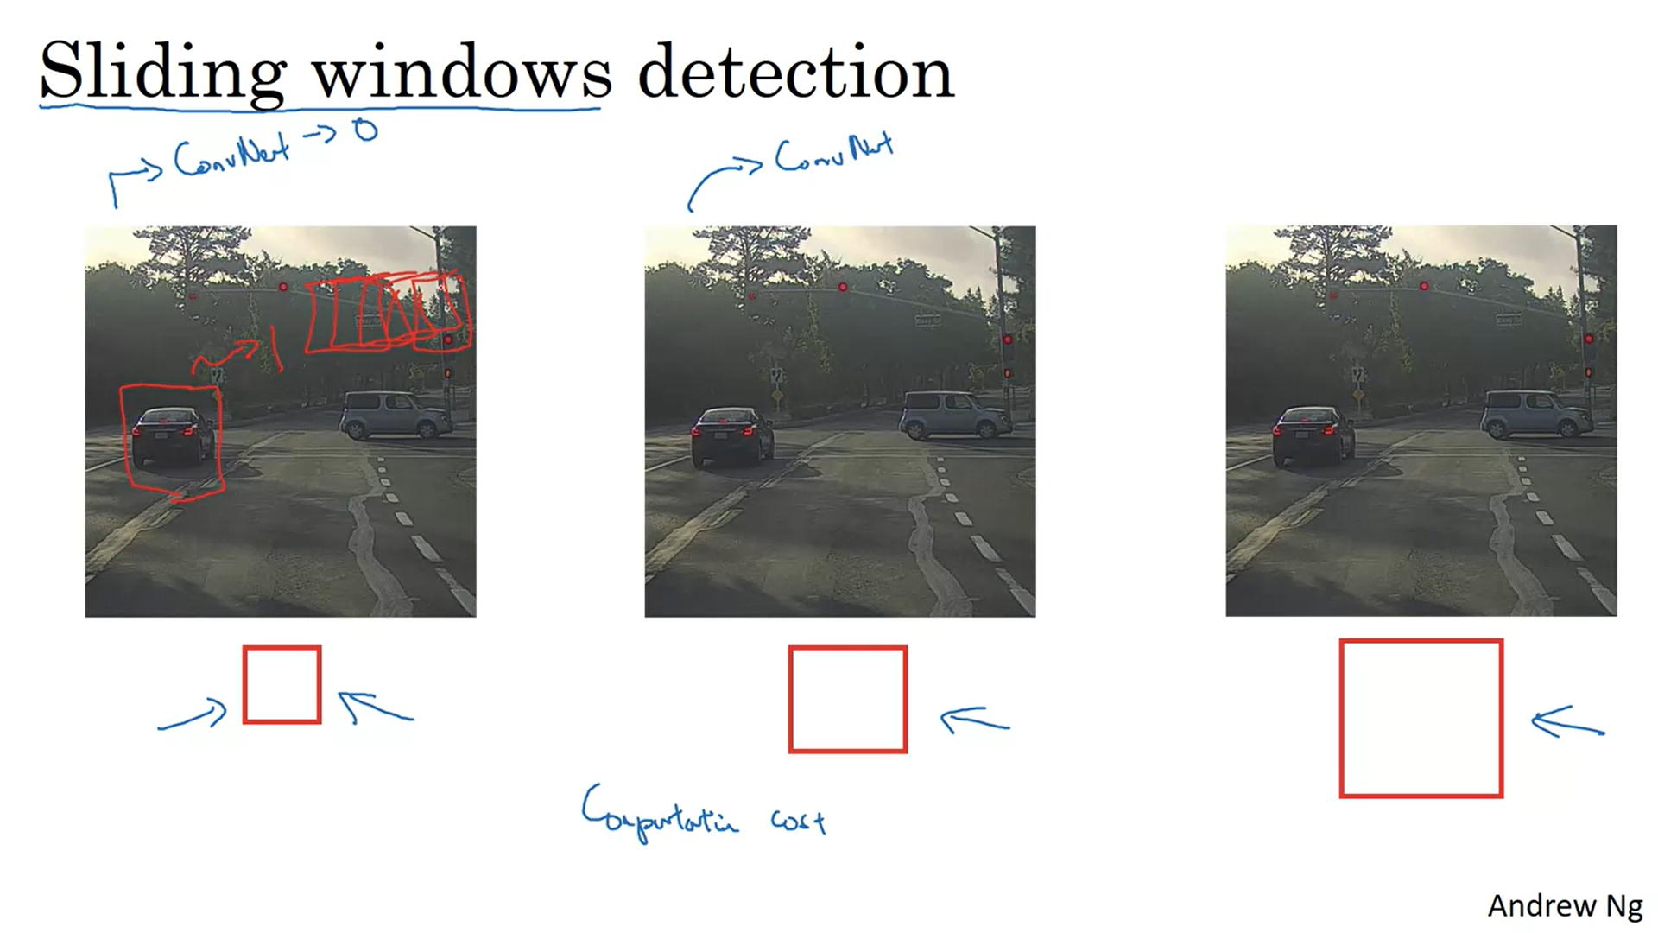

before the rise of Neural Networks people used to use much simpler classifiers like

a simple linear classifier over hand

engineer features in order to perform object detection.

And in that era because each classifier was relatively cheap to compute,

it was just a linear function,

Sliding Windows Detection ran okay.

It was not a bad method,

but with cofinite now running a single classification task is much

more expensive and sliding windows this way is infeasibily slow.

And unless you use a very fine granularity or a very small stride,

you end up not able to localize the objects that accurately within the image as well.

Fortunately however, this problem of computational cost has a pretty good solution.

In particular, the Sliding Windows Object Detector

can be implemented convolutionally or much more efficiently

# Convolutional Implementation of Sliding Windows

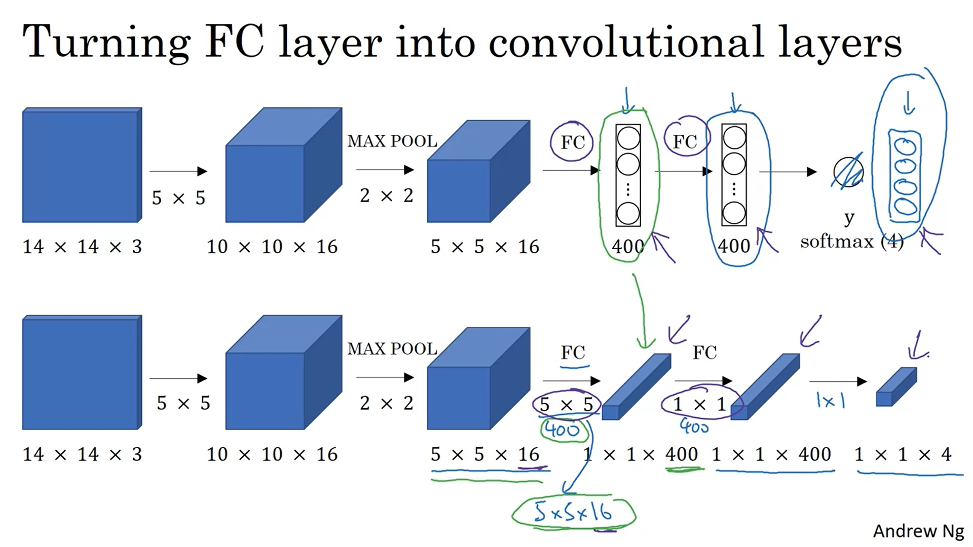

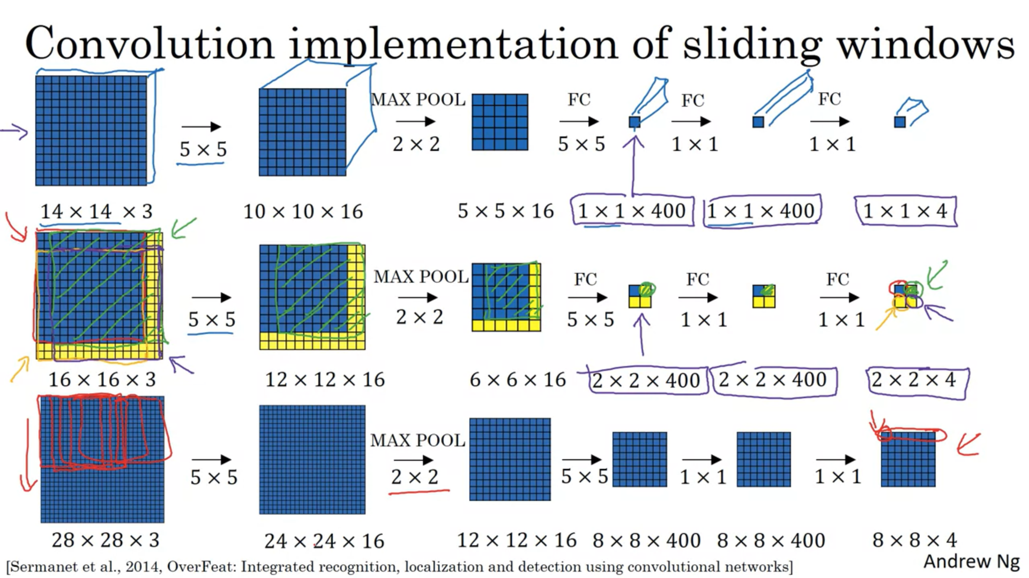

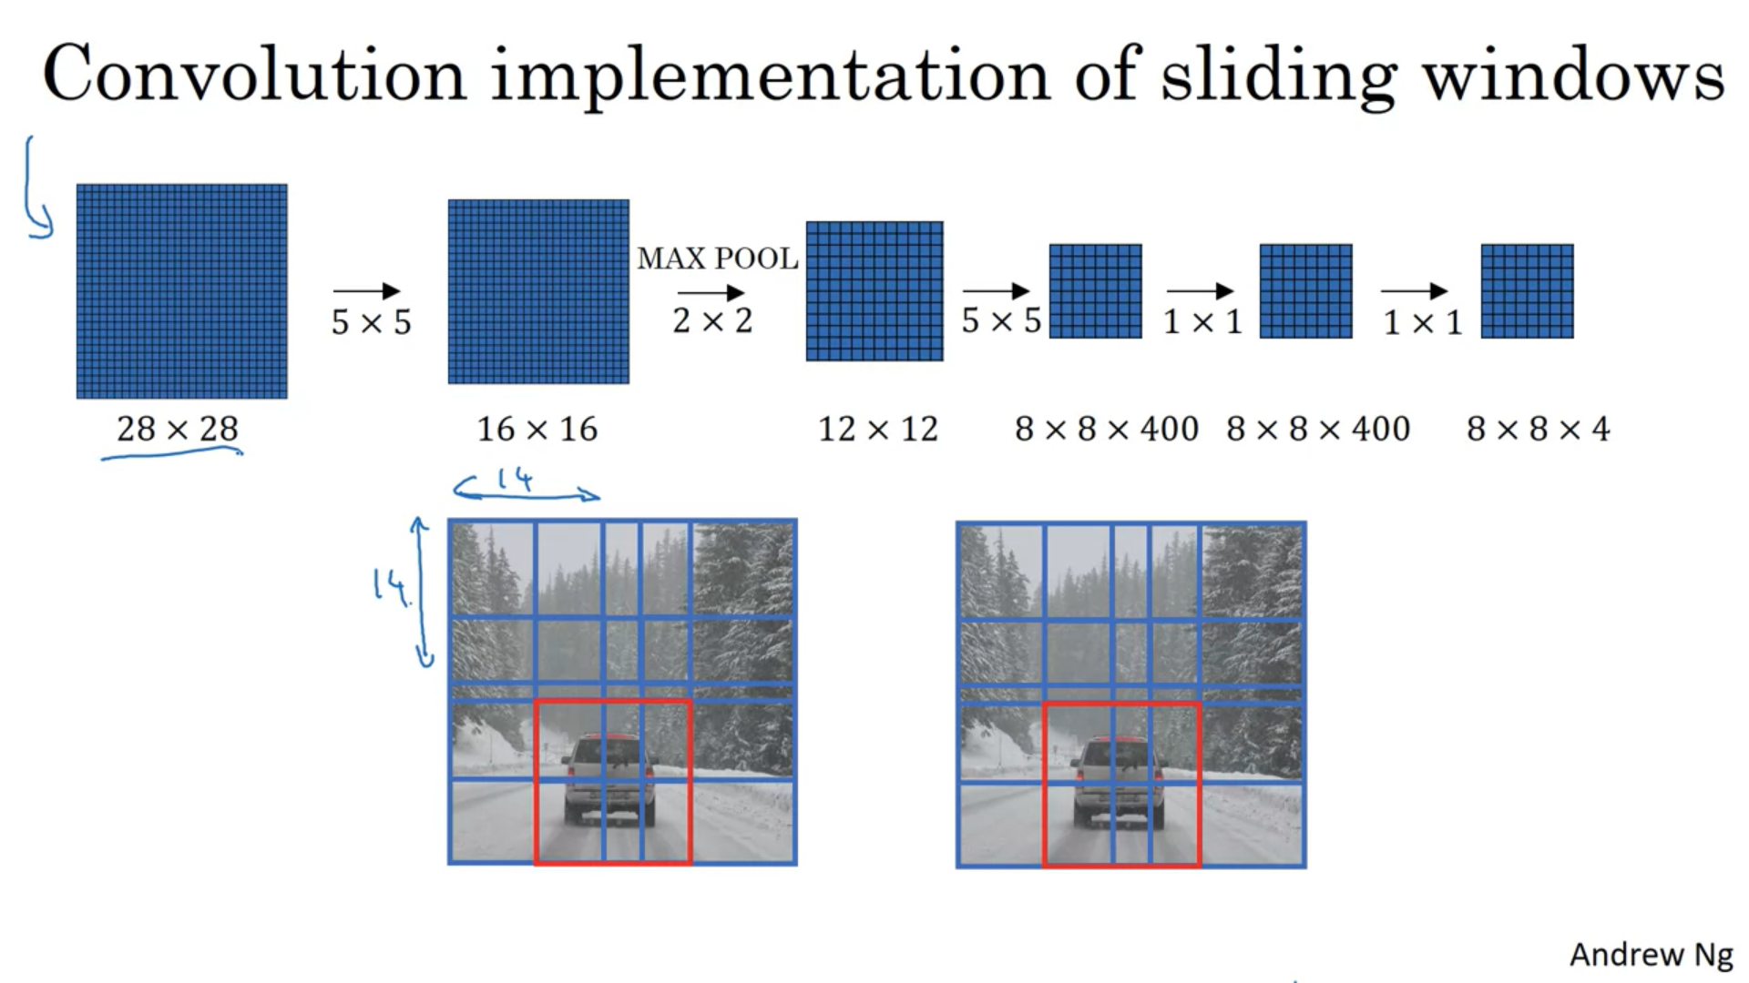

# Bounding Box Predictions

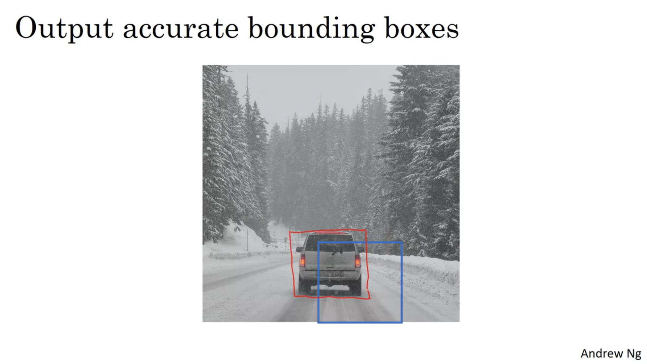

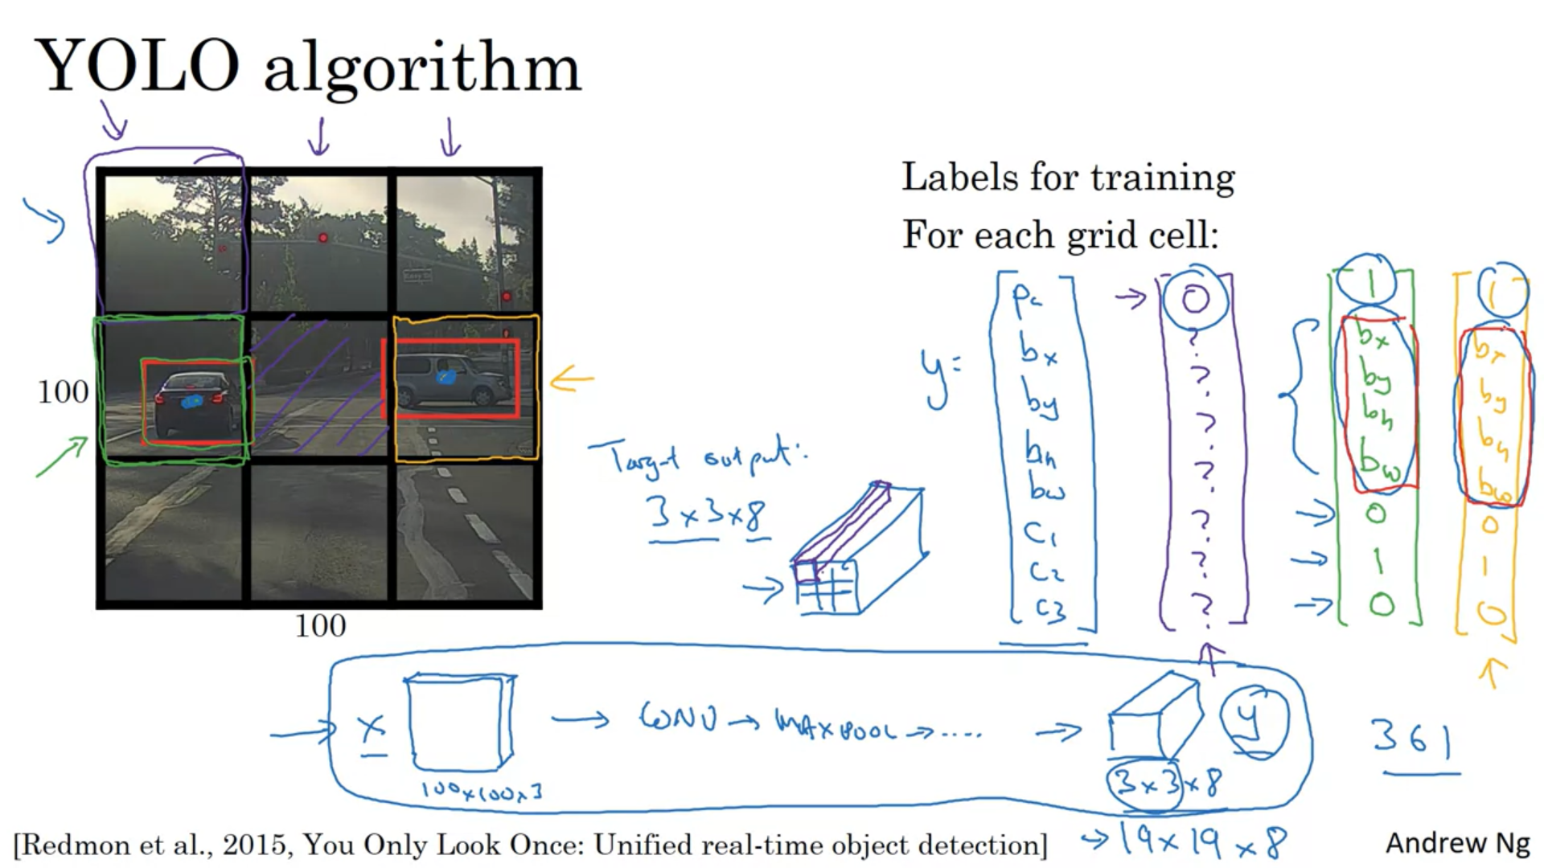

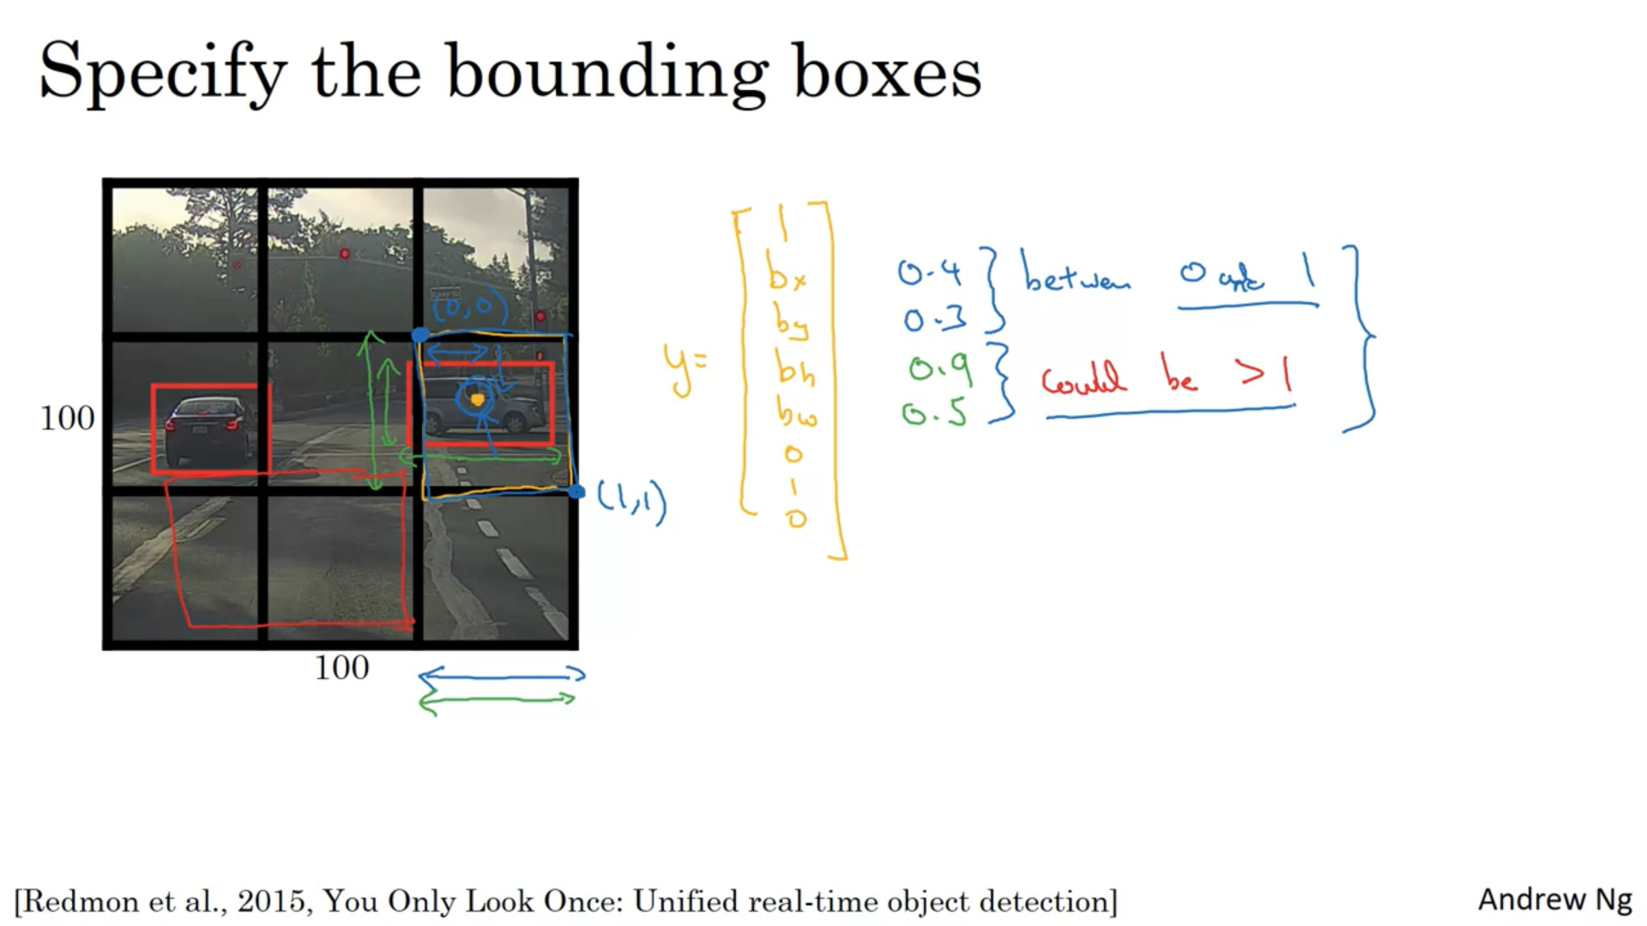

# Intersection Over Union

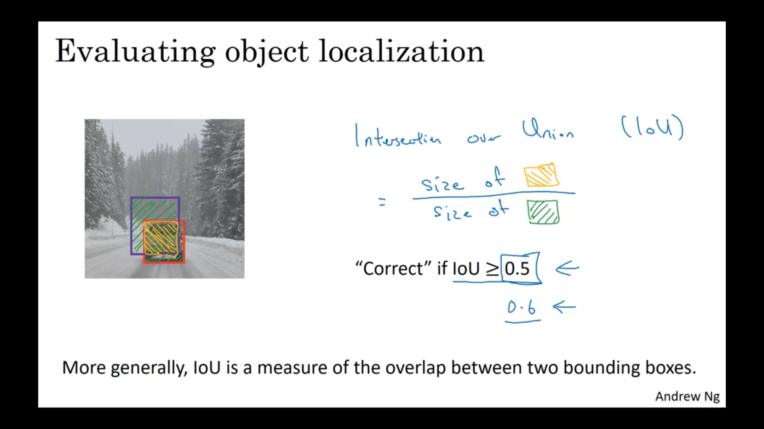

# Non-max Suppression

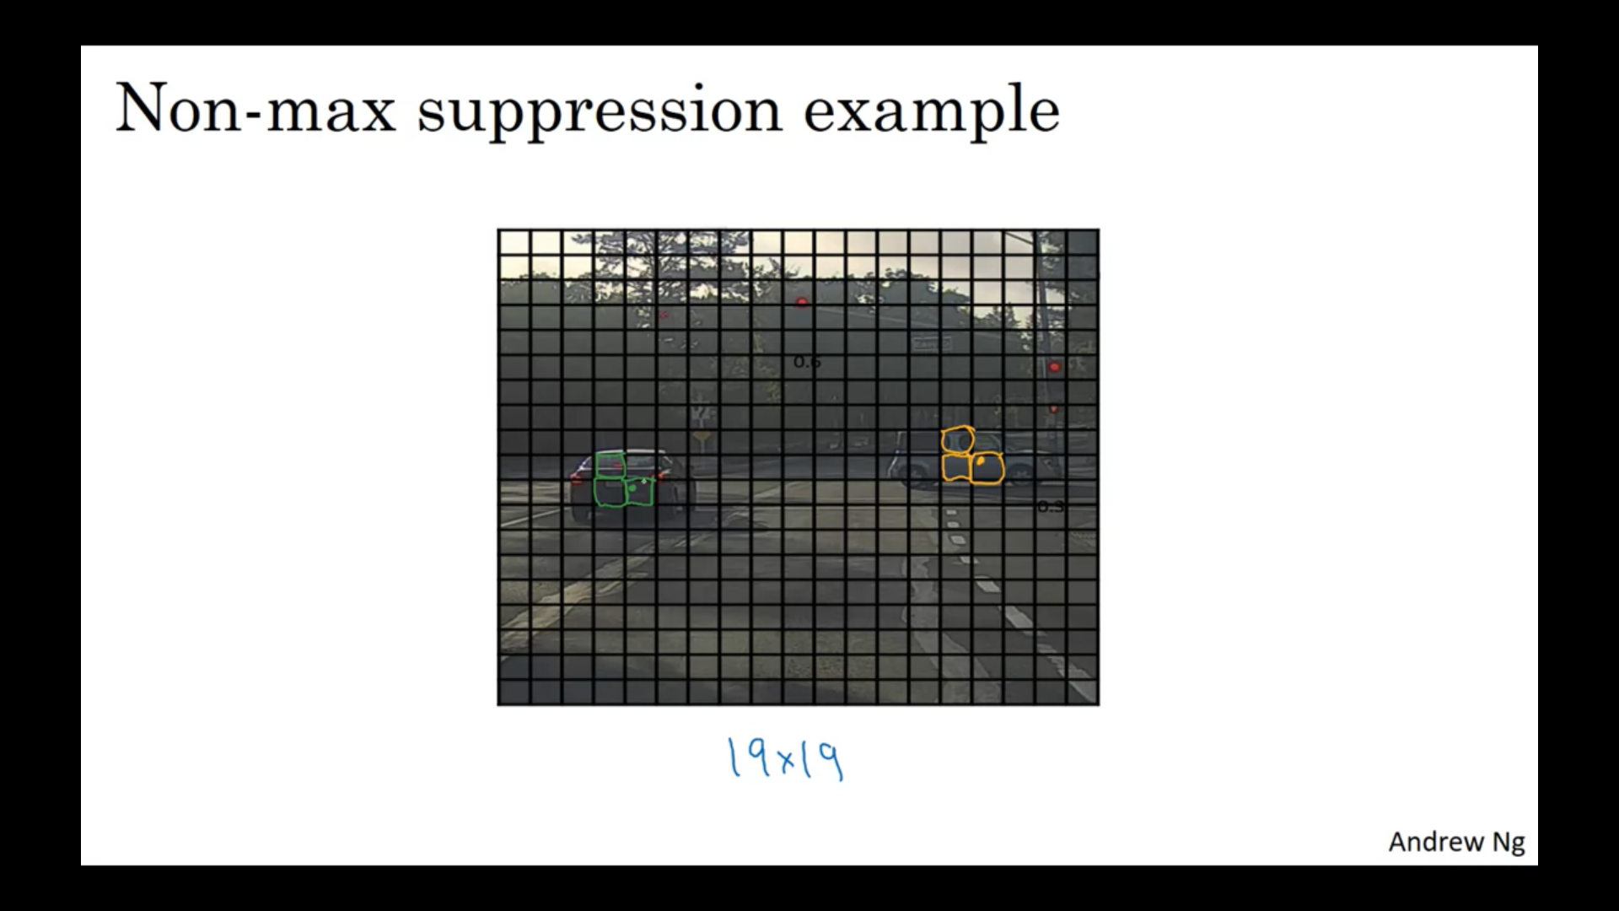

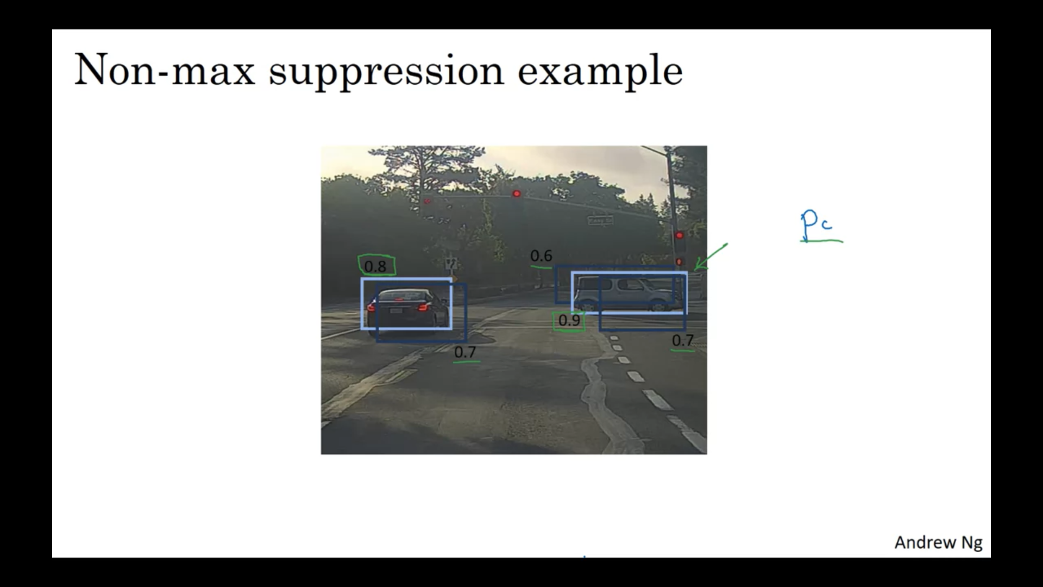

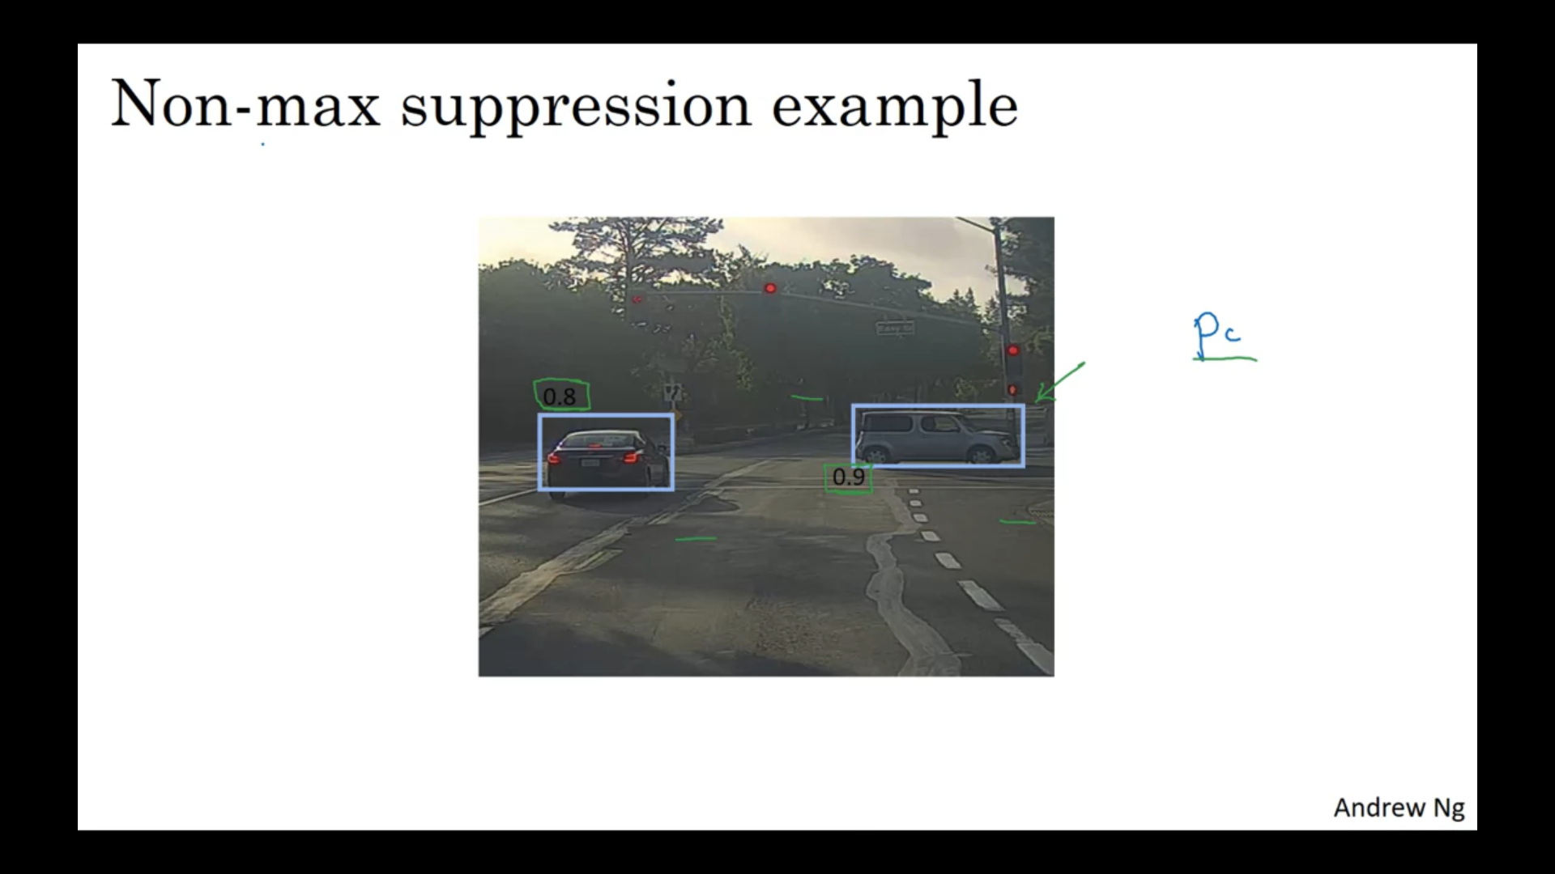

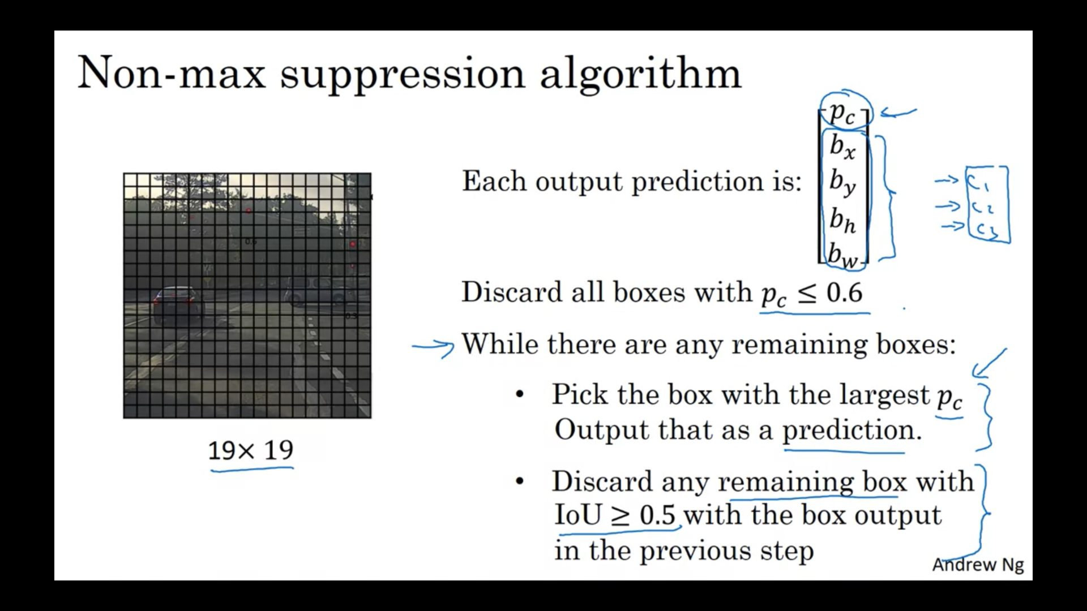

I've described the algorithm using just a single object on this slide.

If you actually tried to detect three objects say pedestrians,

cars, and motorcycles, then the output vector will have three additional components.

And it turns out, the right thing to do is to

independently carry out non-max suppression three times,

one on each of the outputs classes.

# Anchor Boxes

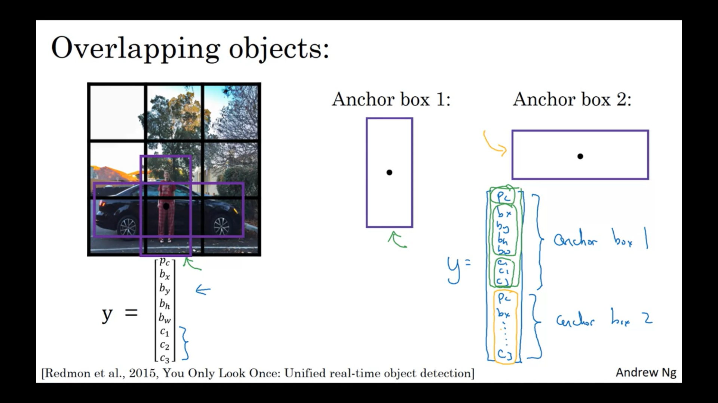

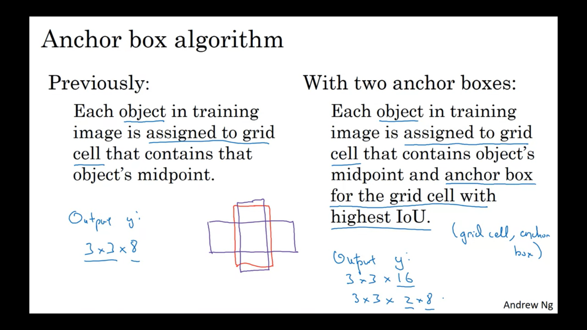

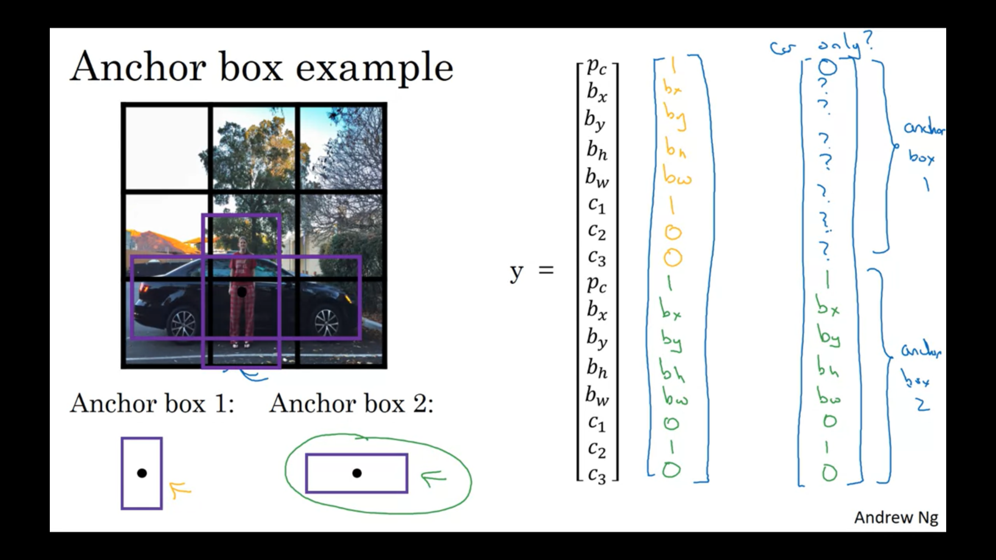

# YOLO Algorithm

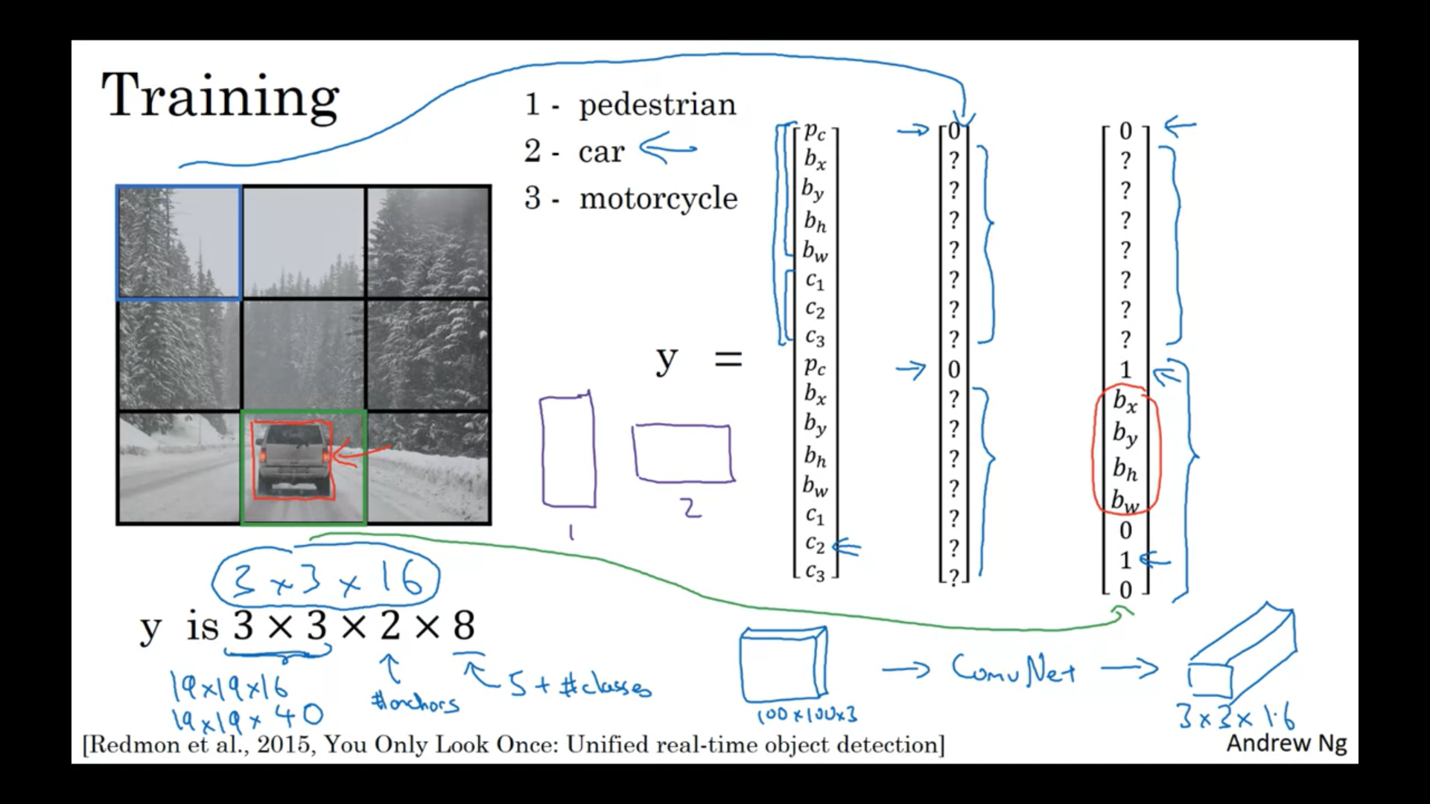

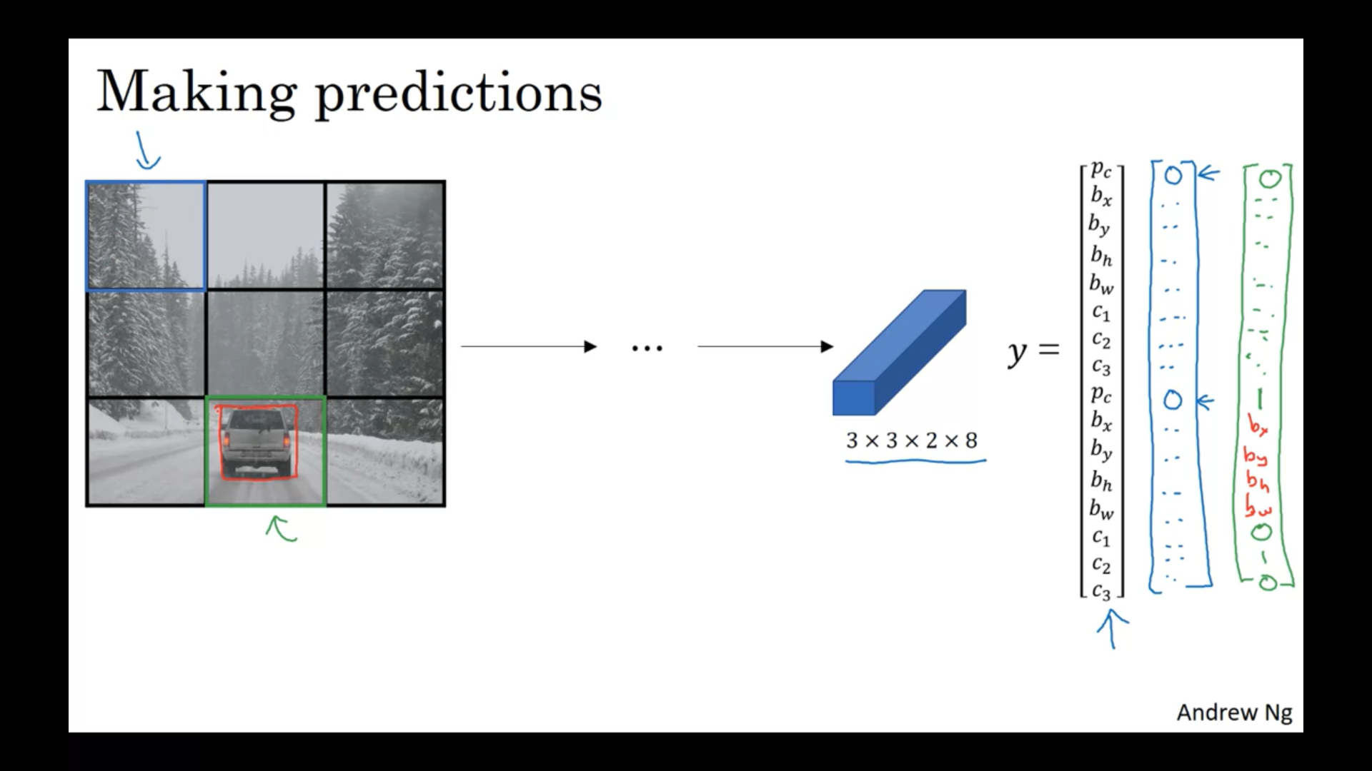

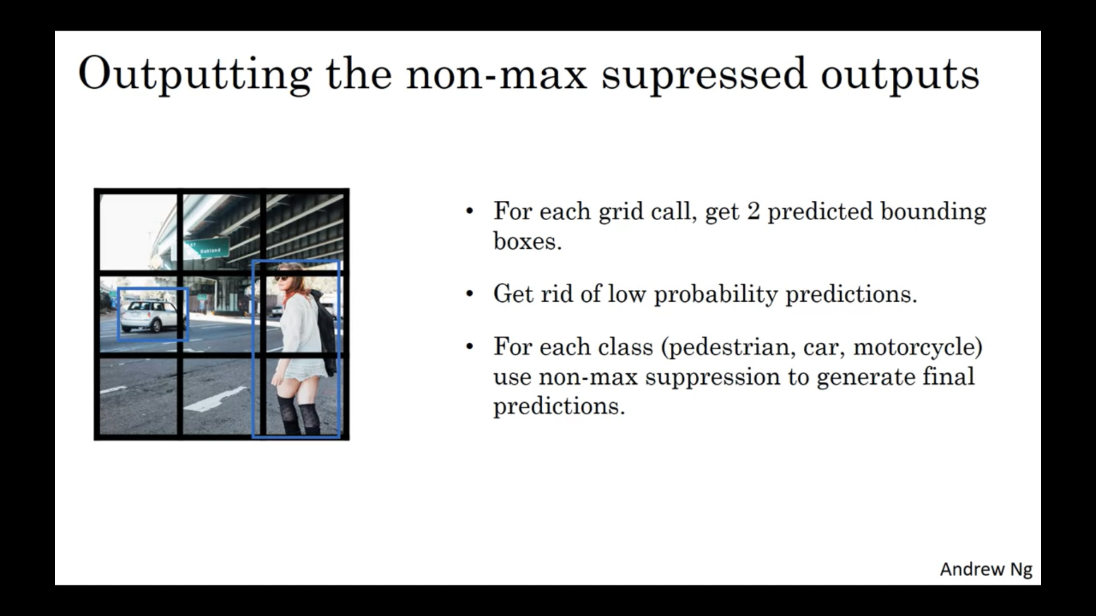

# Region Proposals (not used often)

